Patient Dataset - Cleaning & Analysis Notes
- Dataset Overview
- 105,000 rows, 11 columns
- Columns: patient_id, first_name, last_name, dob, gender, region, postal_code, insurance_type, chronic_diabetes, chronic_hypertension, registration_date

- Data Cleaning Summary
Issue Found | Detail | Fix Applied
Duplicate patients | 5,000 rows fully duplicated after standardizing patient_id | Standardized PAT-0000000 → P0000000 format, then dropped duplicates
Inconsistent gender entries | 14 variants (f, F, FEMALE, Woman, M, Man, etc.) | Mapped to standardized Female / Male / Other / Unknown
Mixed date formats | dob and registration_date had 4 different formats (YYYY-MM-DD, YYYY/MM/DD, MM/DD/YYYY, DD-Mon-YYYY) | Parsed with pd.to_datetime(format='mixed')
Missing/junk postal codes | 2,890 missing + 954 placeholder junk (UNKNOWN, 00000, 123 ABC) + 257 rows using the generic placeholder A1A 1A1 | Validated against Canadian postal code pattern; invalid/placeholder values set to missing
Missing values (various) | Scattered across gender, dob, postal_code | Standardized all missing values to "Unknown"
Whitespace | Leading/trailing spaces in text fields | Stripped across all text columns
Inconsistent casing | Names and gender in mixed case | Converted to Title Case
Result: 105,000 → 100,000 unique, cleaned patient records.

- Descriptive Analysis
Gender
- Female: 52,421 (~51%)
- Male: 50,471 (~49%)
- Other: ~1,994
- Unknown/missing: ~114
- → Roughly balanced; gender unlikely to be a major driver in other comparisons.
Region
- All 8 regions land within ~13,000–13,300 patients each (~2% spread)
- → Distribution is effectively even; no single region is over/under-represented.
Insurance Type
- Public: ~52%
- Private: ~23%
- Employer: ~17%
- Self-Pay: ~6%
- Unknown: ~2%
Chronic Conditions
- Diabetes: ~15% of patients (15,215)
- Hypertension: ~20% of patients (21,185)
- Both: ~4.2%
- Neither: ~70%
- → Hypertension is notably more common than diabetes in this population.
Age
- Mean age: 53.4 years
- Range: ~15–91 years
- Median: 53.4 years

- Trend Analysis
- Monthly new-patient registrations are stable at ~950–1,050/month — no meaningful growth or decline over the 2017–2025 period covered.
- Chronic condition rates by registration-year cohort are flat — no evidence that newer patients are more or less likely to have diabetes/hypertension than older cohorts.

- Segmentation
Age Group Distribution
Age Band | Count
0–18 | 3,412
19–35 | 23,239
36–50 | 20,461
51–65 | 20,173
65+ | 35,833
→ Population skews notably older: 65+ is the single largest group, ~1.7x the next-largest band.
Chronic Condition Rate by Age Band
Age Band | Diabetes | Hypertension
0–18 | 4.3% | 5.7%
19–35 | 4.2% | 6.0%
36–50 | 6.4% | 9.0%
51–65 | 13.4% | 20.3%
65+ | 27.3% | 37.1%
→ Strong, steady increase in both conditions with age — 65+ patients are roughly 6x more likely to have diabetes and hypertension than patients under 35.
Key insight: the overall diabetes/hypertension prevalence (15%/20%) is likely due to population's older age skew
Insurance Type by Region
- Insurance mix (Public ~52%, Private ~23%, Employer ~17%, Self-Pay ~6%) is nearly identical across all 8 regions.
- → Insurance type does not vary by geography.

- Operational Questions — What This Data Can and Can't Answer

Where do operational inefficiencies exist?
The cleaning issues found are themselves evidence of upstream process gaps:
- Duplicate patient records (5,000) — two ID formats (P0000001 vs PAT-0019757) suggest two intake systems or a change in how info got ingested, causing the same patient to be registered twice.
- 14 gender spellings — indicates a free-text entry field rather than a controlled dropdown; every entry depends on how staff typed it.
- 4 mixed date formats — no standardized data entry format or validation at point of entry.
- ~3,800 missing/junk postal codes — staff either skipped the field or entered placeholder text to bypass a required-field check, rather than the system enforcing valid input.
Conclusion: the inefficiency isn't in a visible workflow, but in the intake/data-entry process itself — no standardization, no validation, likely manual re-keying between systems. Potential for ai automation?

What processes could potentially be automated?
- Dropdown field for gender instead of free text
- Single date-picker instead of allowing any typed format
- Real-time postal code format validation at the point of entry
- Single, consistent patient ID scheme with duplicate-check-on-registration to catch re-registrations before they happen

How can AI/automation improve productivity and consistency?
The cleaning script built for this dataset is itself an example: removing duplication, gender standardization, date parsing, and postal code validation were all done programmatically. At 105,000 rows, this would take a human analyst hours to days to do manually — a script does it in seconds, and does it the same way every time. This directly addresses "consistency," since manual correction is subject to different staff interpreting ambiguous entries differently.

Which activities consume the most staff time?
This dataset contains no time-tracking, appointment, or staffing data, so this question cannot be answered with evidence from this file. At most, one could note that manual data correction/re-entry is likely time-consuming given the volume of errors found — but there is no actual time data to support a specific number or ranking. This is a genuine gap that would require appointment logs, staff time sheets, or workflow timing data to answer properly.

- Suggested Next Steps
- If available, bring in appointment/visit logs, staff time sheets, or billing/claims data to answer staff-time, financial, and true operational-efficiency questions.
- Consider a predictive model for chronic condition risk (age is the dominant driver found here; a model would mostly confirm this rather than reveal new drivers without richer clinical data).
- Recommend input validation at the data-entry layer (dropdowns, date pickers, postal code format checks) as a low-cost fix that would prevent most of the cleaning issues found in this dataset from recurring.

Gender Distribution
- Roughly even — 52,421 Female vs 50,471 Male (~51%/49%), with small Other (~2,000) and Unknown/missing (~114) bars.
- Nothing skewed here; the population is balanced by sex, so gender likely won't be a strong driver in any downstream comparison.
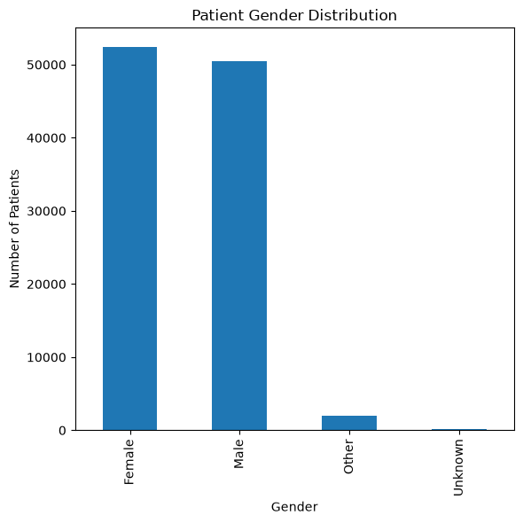

Patient Distribution by Region
- Nearly identical
- All 8 regions land within a tight band (~13,000–13,300 patients each). Essentially flat — no single region dominates or is underrepresented.
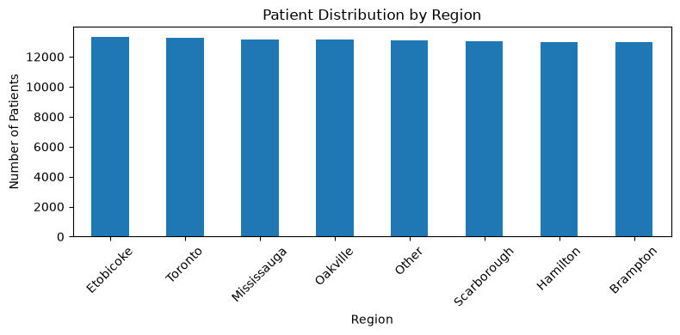

Patient Age Groups
- most skewed chart in the set: 65+ is by far the largest group (35,833 patients) — more than any other single band, and almost 1.7x the next-largest group (19-35, at 23,239).
- The 0-18 group is small (3,412) by comparison. Therefore, patient population is meaningfully older-skewing, not evenly spread across ages.
- Skews towards older patients – more older patients registered than younger patients
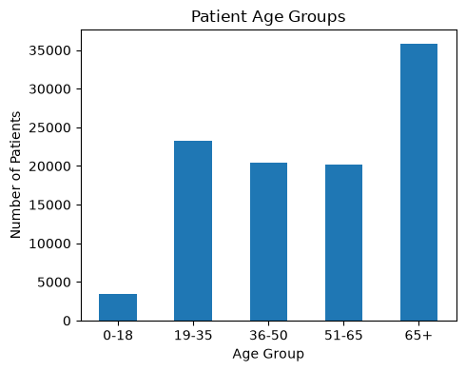

Insurance Type by Region
- The bars will look almost identical shape across all 8 region clusters — Public dominates in every region (~51-52%), then Private (~22-24%), then Employer (~17%), then Self-Pay (~6%).
- The key interpretation: insurance mix does not vary meaningfully by region — whatever influences insurance type, it isn't geography.
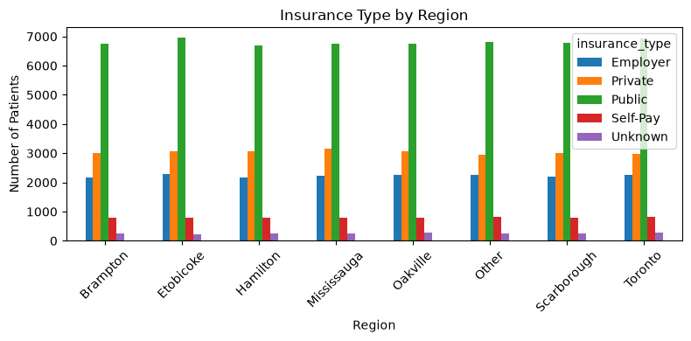

Diabetes / Hypertension Prevalence and Chronic Condition by Age
- Diabetes: ~15% of patients (15,215 of ~105,000)
- Hypertension: ~20% of patients (21,185)
- Hypertension is noticeably more common than diabetes in this population, and both occur more often in patients who are older.
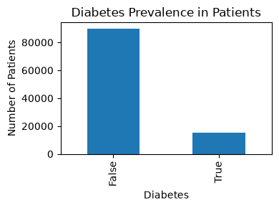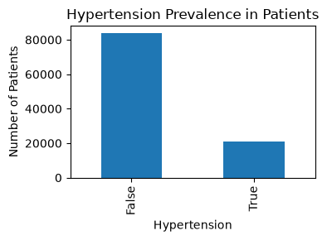
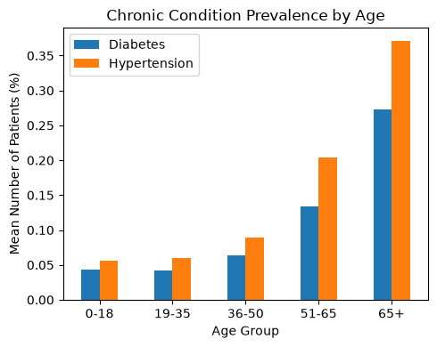

Takeaway:
Age skews older (65+ is the biggest group) and condition rates by age band climb steeply with age (65+ patients have ~27% diabetes and ~37% hypertension, vs. ~4-6% in the under-35 groups). So the age distribution chart and the diabetes/hypertension charts aren't independent facts — the overall diabetes/hypertension prevalence numbers are large because patient population is older.

